Original Title.
Format: Times New Roman #14, bold, centered
The article title, limited to a maximum of 15 words, must be provided in both Spanish and English and clearly and concisely convey the article’s content

Translated Title.
Format: Times New Roman #14, bold, centered

[Editor’s Note: When submitting the manuscript, author information must be omitted, and we recommend reviewing the “Submissions” section on the journal’s website for further information.]

Abstract:
Format: Times New Roman #12, justified.
Please submit an abstract in Spanish and an abstract in English, each no longer than 150 words, outlining the article’s objective, spatial and temporal scope, methodology, characteristics of the research sample (if applicable), results, limitations, significance, and conclusions.

Keywords:
Format: Times New Roman #12, justified. Separated by commas. Include a list of 3 to 5 keywords in Spanish and English.

Abstract:
Format: Times New Roman #12, justified. Separated by commas. Include a list of 3 to 5 keywords in Spanish and English.

Section 1
Format: Times New Roman #16, bold, centered.

The article must have a clear structure and include sections and subsections that are properly organized and distinguished solely through the use of typography, without using Arabic or Roman numerals.

Article Text
Format: Times New Roman #12, justified.
The minimum structure of the article must include an introduction that clearly outlines the background of the work, the research approach, the objective, and the structure of the article, followed by the methodology used and the main body of the text, and concluding with the conclusions and references cited.
Articles written in Microsoft Word, including text, tables, and figures, must be between 8,000 and 10,000 words in length, formatted on letter-size paper with 2.54-centimeter margins, using 12-point Times New Roman font, justified paragraphs, single spacing, and no spaces between paragraphs or line breaks. Pages must be paginated from the first to the last in the lower right margin.
When using acronyms and abbreviations in the body of the text, write out the full name the first time they are mentioned, followed immediately by the abbreviation in parentheses. Example: United Nations (UN); thereafter, use only UN.

Articles should not include annexes or appendices; therefore, all information must be included in the main text or footnotes.

Articles should not include headings.

Announcement text
Format: Times New Roman #12, Justified. 4 cm margin on the left

Footnotes
Format: The footnote reference should be displayed as a superscript. Times New Roman, #12, justified

Figures: figures, charts, photos, maps, diagrams, etc., should be inserted immediately after they are mentioned at the end of the paragraph.

Source: Times New Roman #12. Centered. Normal
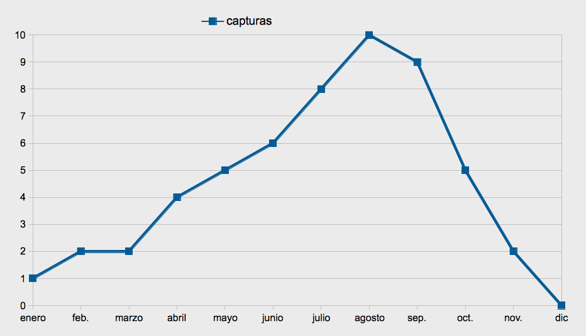
Figure 1. Figure title, Times New Roman #12. Centered. Normal

Figures (graphs, diagrams, maps, photographs, etc.), preferably in color, should be numbered consecutively using Arabic numerals and inserted into the body of the text as close as possible to where they are mentioned in the article. The title should be placed at the bottom of the figure, and the caption at the top.

Equiations
$$A=πr^{2}$$
If the article includes equations or mathematical notation, use Microsoft Word's equation editor.

Tables

Table 1. Table title, Times New Roman #12, centered, normal
Sourde: Times New Roman #12, centered, normal

Tables should be numbered consecutively in ascending order using Arabic numerals and should be included in the main text as close as possible to where they are mentioned in the article. The title should be placed at the top of the table, and the source should be cited at the bottom of the table.

Level 2 headling. Times New Roman #14, bold, centered

Paragraph: Times New Roman #12, justified.

Section level 3. Times New Roman #13, bold, centered

Paragraph: Times New Roman #12, justified.

References. Times New Roman #12, bold, left-aligned.
1 line per reference. Times New Roman #12, justified.

Last Name, First Name. (year). Reference text.

The author's brief CV should be included after the References.

Author name: Times New Roman #12, left-aligned.
Text: Times New Roman #12, justified.
Include nationality. Highest academic degree and the institution where it was earned. Current affiliation. Areas of research. A recent publication.

Footnote text: Times New Roman #12, justified. Footnotes should appear at the bottom of the page, in Times New Roman, 12-point font, with single spacing, no space between footnotes, and justified text.

